Exp 26: Transaction Level Modeling (TLM) using SystemC
Program:
// Code your testbench here.
// Uncomment the next line for SystemC modules.
// #include <systemc>
#include <systemc>
#include <tlm>
#include <tlm_utils/simple_initiator_socket.h> #include <tlm_utils/simple_target_socket.h> using namespace sc_core; using namespace tlm; using namespace std;
// Target struct Target : sc_module { tlm_utils::simple_target_socket<Target> socket; SC_CTOR(Target) : socket("socket") { socket.register_b_transport(this, &Target::b_transport);
}
void b_transport(tlm_generic_payload& trans, sc_time& delay) { int* data = (int*) trans.get_data_ptr(); cout << "Target received: " << *data << endl; delay += sc_time(10, SC_NS);
}
};
// Initiator struct Initiator : sc_module { tlm_utils::simple_initiator_socket<Initiator> socket;
SC_CTOR(Initiator) : socket("socket") {
SC_THREAD(thread_process);
}
void thread_process() { tlm_generic_payload trans; sc_time delay = SC_ZERO_TIME; int data = 555; trans.set_data_ptr(reinterpret_cast<unsigned char*>(&data)); trans.set_data_length(sizeof(data)); cout << "Initiator sending: " << data << endl; socket->b_transport(trans, delay); wait(delay);
} };
int sc_main(int argc, char* argv[]) {
Initiator initiator("initiator"); Target target("target"); initiator.socket.bind(target.socket); sc_start(); return 0;
}
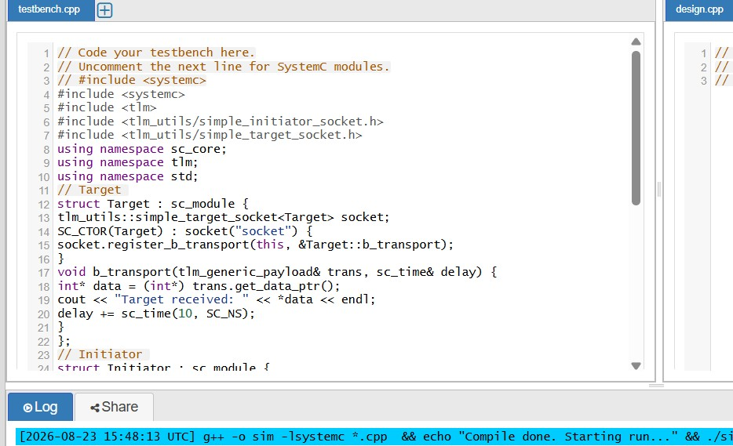
Output:
